**Note: If both Judge Edition and Clerk Edition will be installed on the same computer, install SQL Server using the Judge Edition configuration settings.**

**Install Microsoft .NET Framework 4**

You must install Microsoft .NET Framework 4 or higher on each PC where SessionWorks will be installed

1. Navigate to the .NET homepage: [http://www.microsoft.com/net/.](http://www.microsoft.com/net/)

2. Click the download link.

3. Follow the instructions to install the framework.

**Install SQL Server Express 2014**

**NOTE: SQL Server only needs to be installed on the PC that will have the central services installed on it.**

1. Navigate to the *SQL Server Express* installation home page: [http://www.microsoft.com/express/ Database/InstallOptions.aspx.](http://www.microsoft.com/express/Database/InstallOptions.aspx) <https://www.microsoft.com/en-us/download/details.aspx?id=42299>

2. Scroll to the middle of the web page to the “Technical overview” section

3. Click the **Download SQL Server 2014 Express** link.

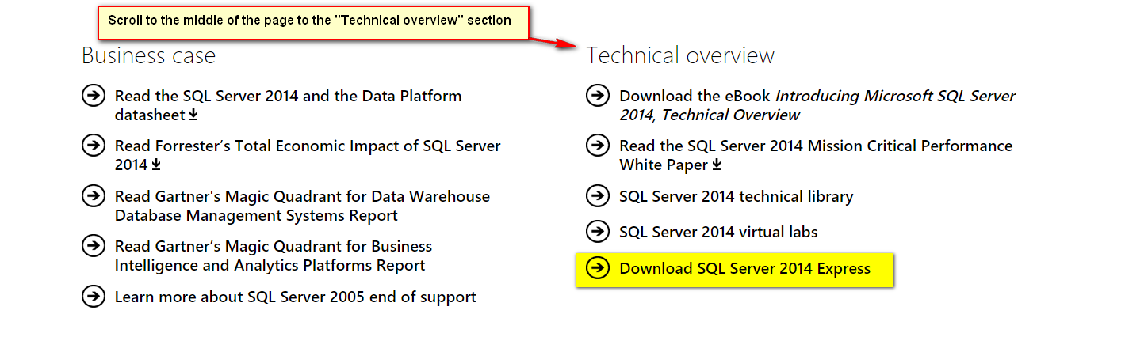

4. Sign on to Microsoft account (create if necessary)

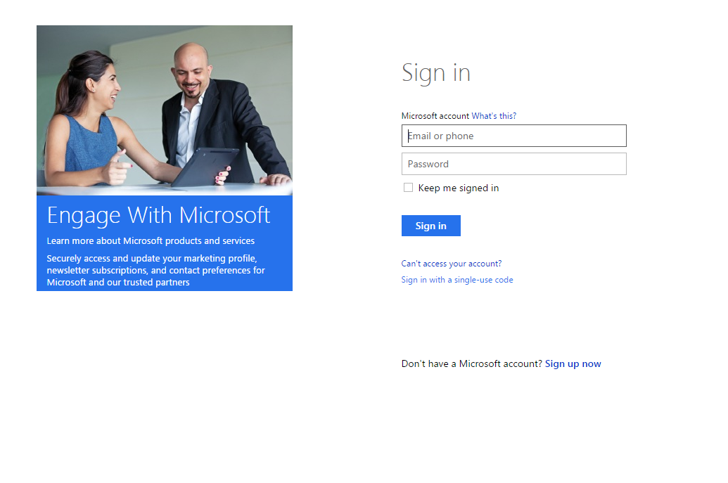

5. Under the Microsoft “Profile Center” check the radio button for SQL Server 2014 Express 64 Bit

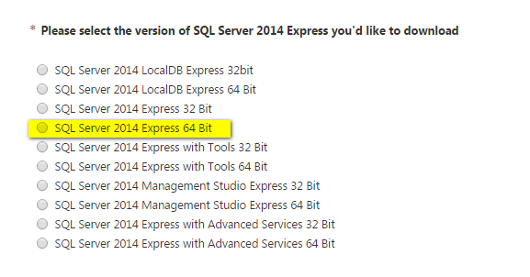

6. Select a language from the **64-Bit** drop-down list, and then click the **Download** button.

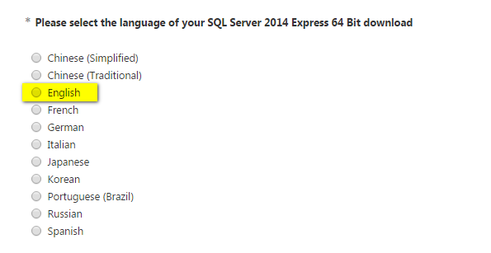

7. Click continue

8. Double-click the downloaded executable at the bottom of the page



9. Click “Run”

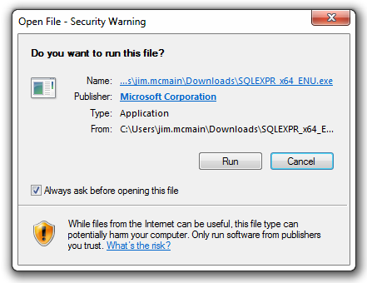

10. Click Ok (to accept the default directory)

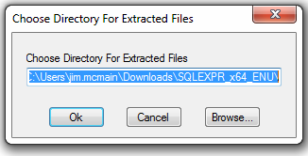

11. Click the **New SQL Server stand-alone installation or add features to an existing installation** link.

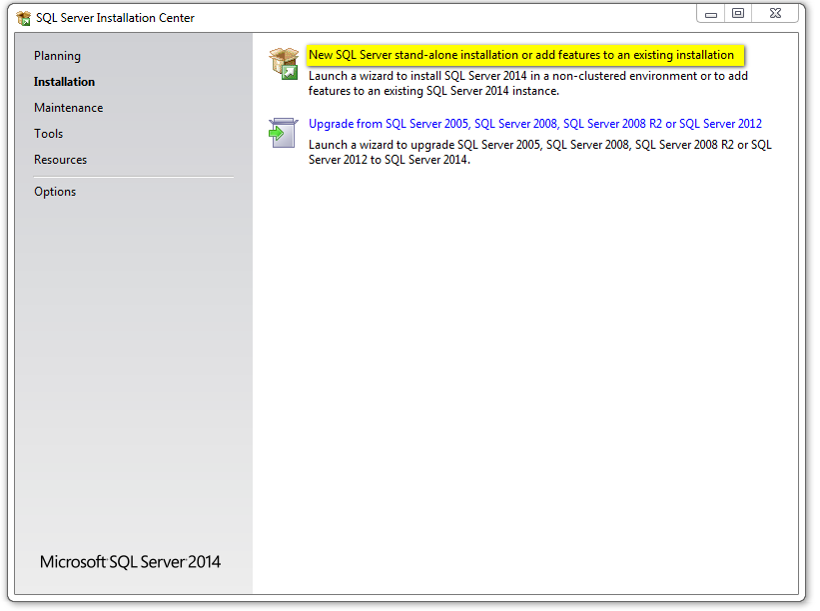

12. Select the **I accept the license terms** check box on the *License Terms* dialog box and click “Next”

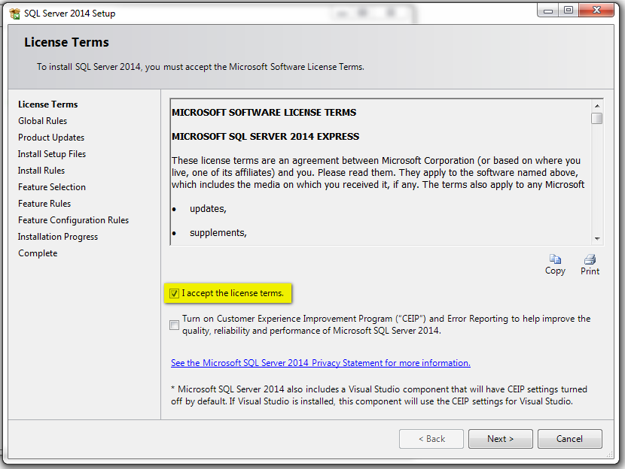

13. The *Feature Selection* dialog box will be displayed. Keep all feature selection defaults and click Next.

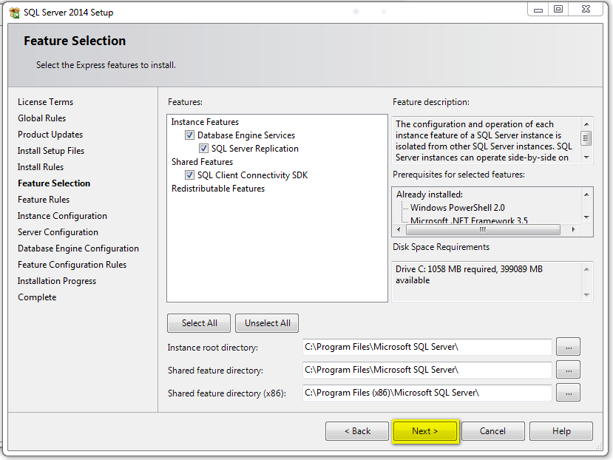

14. The *Instance Configuration* dialog box will be displayed. Click “Next”

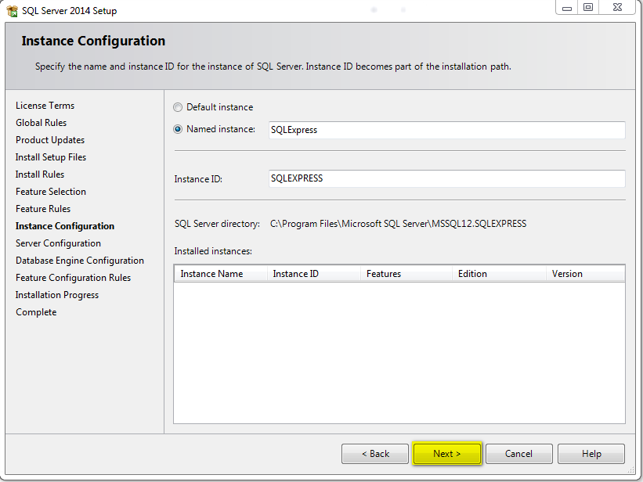

15. Select **Automatic** from the SQL Server Browser **Startup Type** drop-down menu then select “Next”

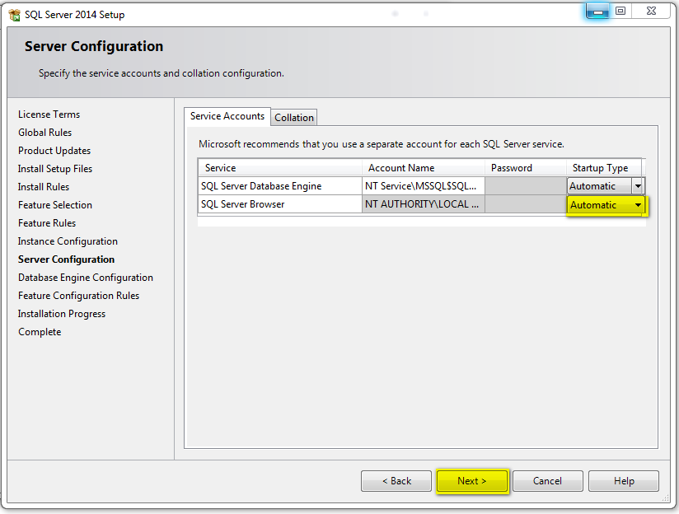

16. Change the following settings on the *Database Engine Configuration* dialog box:

a. Select the **Mixed Mode** option.

b. Type a password for the system administrator (sa) account.

c. Accept your user name to be a SQL Server Administrator, or change it to be

BUILTIN\Administrators, or change it to another group of your choosing. The user that will later install the SessionWorks services must be a member of this SQL Server Administrators Group.

d. Click Next.

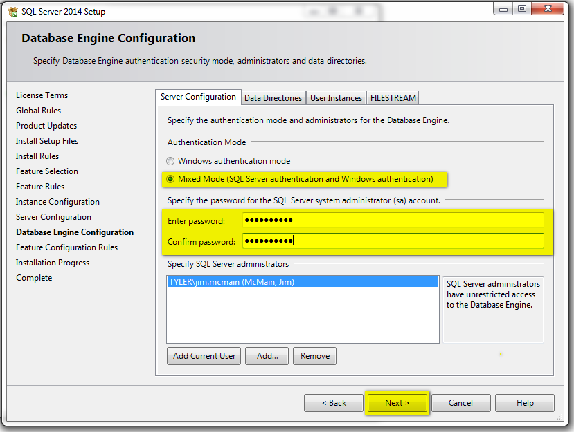

Kane password is set to “itd”

17. SQL Server will install on your system. Click **Close** on the *Complete* dialog box to complete this part of the installation.

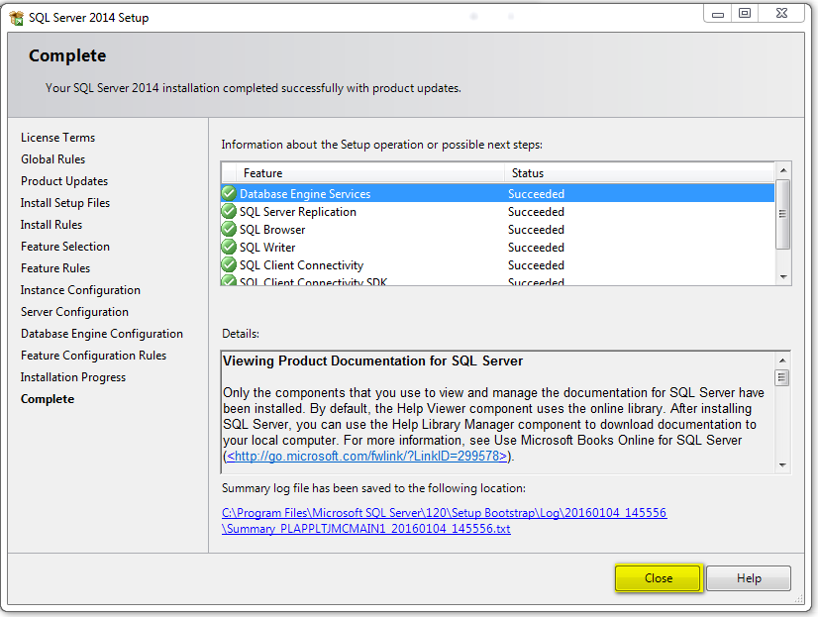

17. Click the **X** in the upper-right corner of the window to dismiss the *SQL Server Installation Center* dialog box.

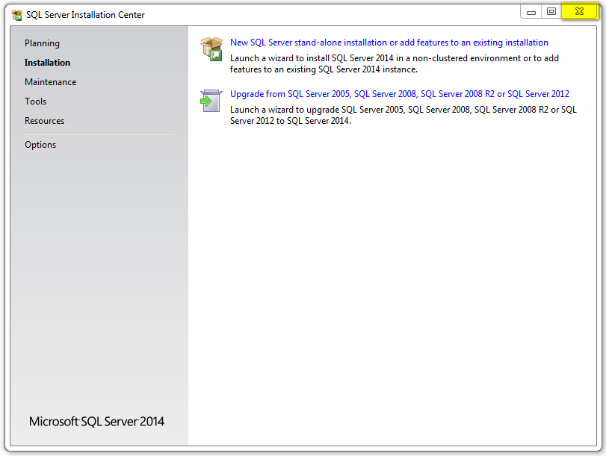

**Allowing TCP/IP Connections to SQL Express**

This section provides step-by-step instructions on allowing TCP/IP connections to SQL Express. Complete the following steps to allow TCP/IP connections to SQL Express:

1. Open **SQL Server Configuration Manager** from Window’s **Start** menu.

**Figure 3.13 – Windows Start Menu**

2. Expand the **SQL Server Network Configuration** item in the left pane.

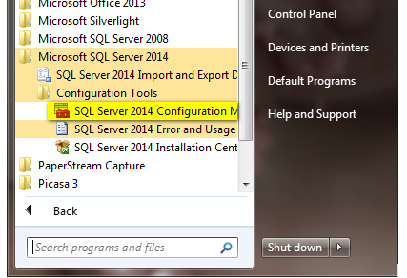

3. Expand “SQL Server Network Configuration”

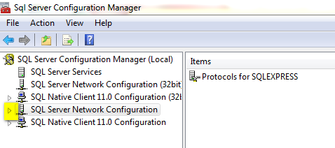

4. Click on “Protocols for SQLEXPRESS”

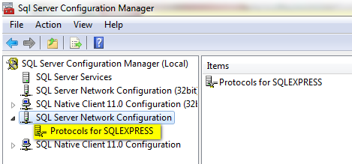

5. Right-click **TCP/IP** in the right window, and then select **Enable**. (Warning message will display, click “Ok”)

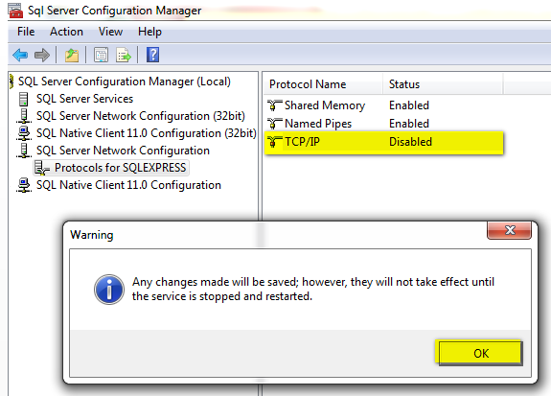

6. SQL installation is now complete and you can close Sql Server Configuration Manager.

Need to restart the services go to SQL Services

**Updating Windows Firewall For Remote Connections (If Judges Travel From Courtroom to Courtroom)**

This sections provides step-by-step instructions on how to update your Windows Firewall. Complete the following steps to update the Windows Firewall.

 **Note: If your county or state uses other firewall software, refer to its documentation to accomplish the following tasks.**

1. From the **Administration Tools** menu, select **Windows Firewall with Advanced Security**.

 **Note: There are several ways to open the Administrative Tools menu. The following figure shows one of many ways to open the Administrative Tools menu.**

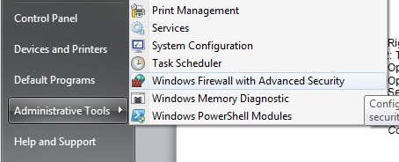

The following menu is displayed:



2. Select **Inbound Rules**, and then click **New Rule...** in the right pane.

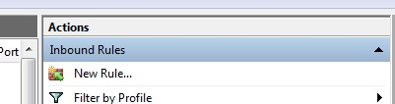

**Figure 3.19 – Actions Window**

3. Click the **Program** option, and then click **Next**.

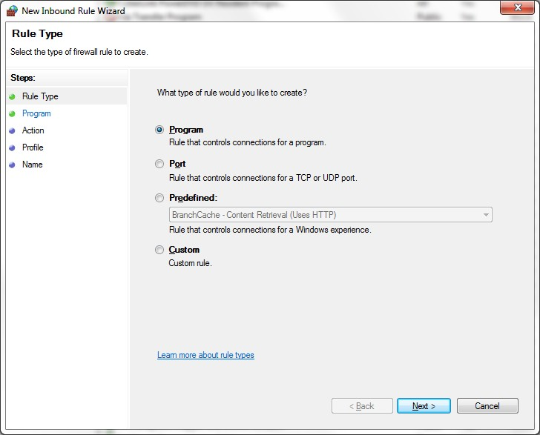

**Figure 3.20 – New Inbound Rule Wizard (Rule Type) Dialog Box**

4. Select the **This program path** option.

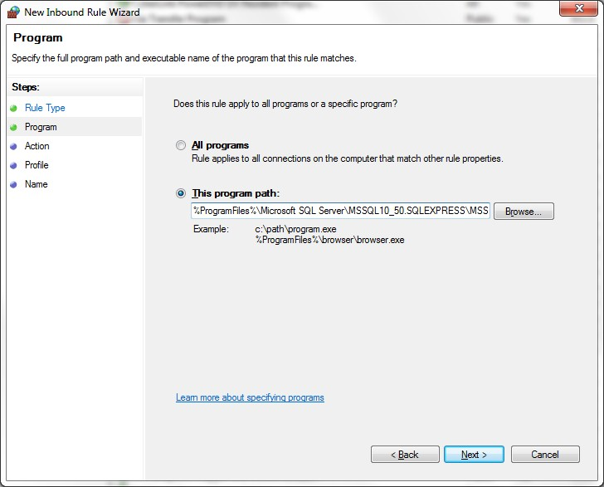

**Figure 3.21 – New Inbound Rule Wizard (Program) Dialog Box**

5. Click **Next**.

6. Browse to the sqlservr.exe you previously installed. This is normally found in the following directory if you accepted the default installation path: C:\Program Files\Microsoft SQL Server\MSSQL10_50. SQLEXPRESS\MSSQL\Binn\sqlservr.exe.

**OR** –

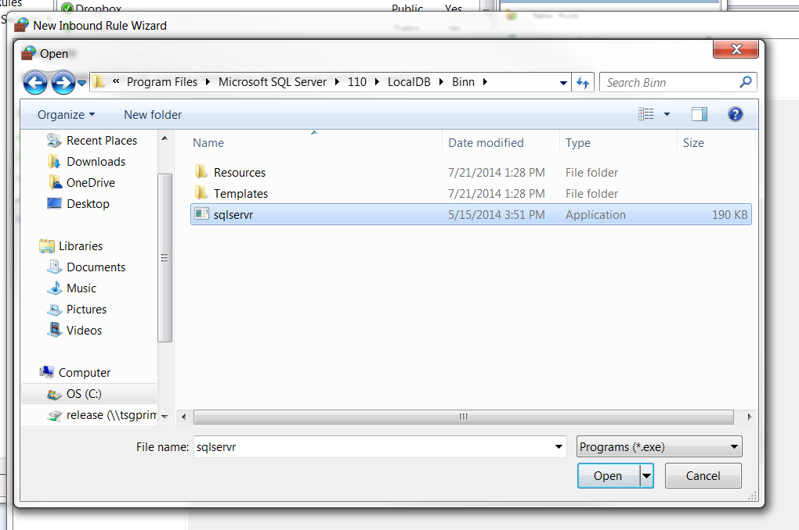

7. Click **Next**.

8. Click the **Allow the connection** option.

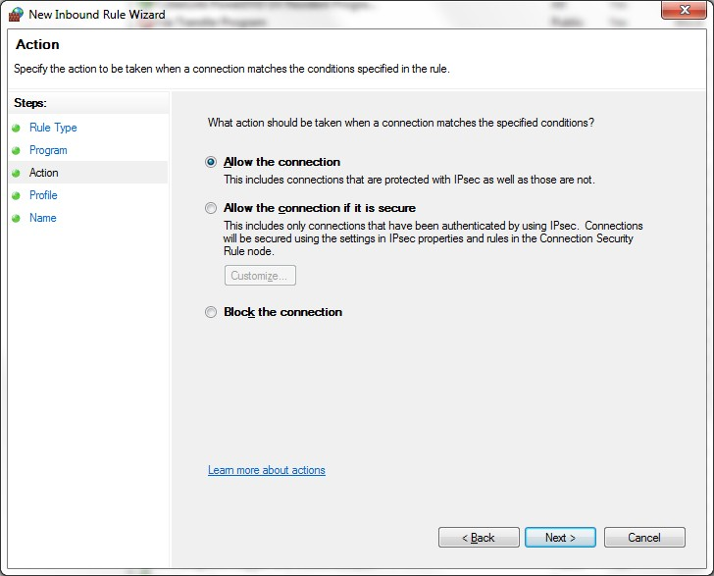

**Figure 3.22 – New Inbound Rule Wizard (Action) Dialog Box**

9. Click **Next**.

10. Select the **Domain** check box.

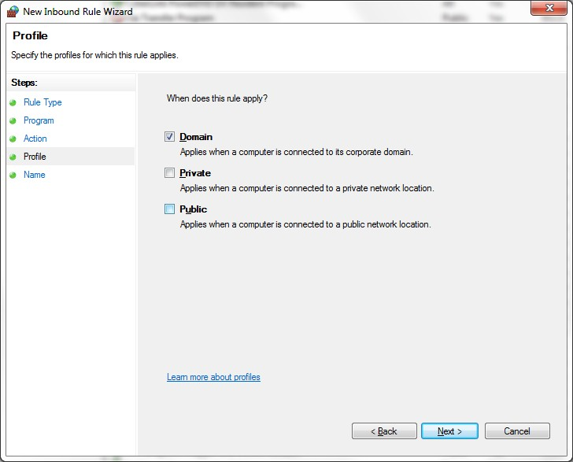

**Figure 3.23 – New Inbound Rule Wizard (Profile) Dialog Box**

11. Click **Next**.

12. Give this rule a name, such as **SQL Server Express**.

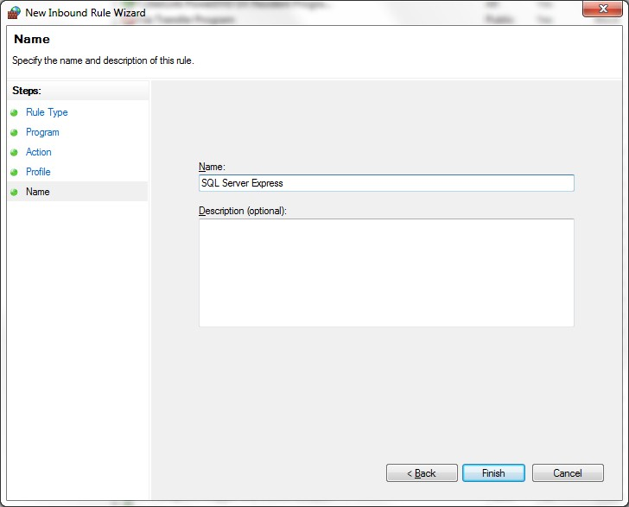

**Figure 3.24 – New Inbound Rule Wizard (Name) Dialog Box**

13. Click **Finish**.

14. Add another rule by clicking **New Rule**. The *Rule Type* dialog box will be displayed.

15. Click the **Port** option.

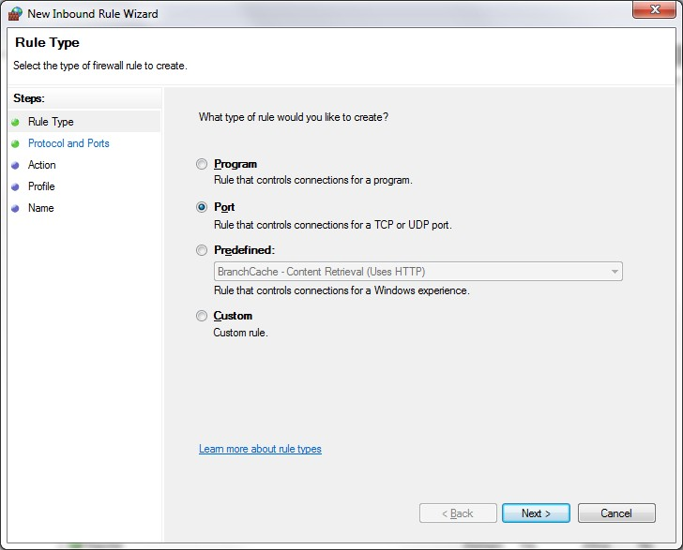

**Figure 3.25 – New Inbound Rule Wizard (Rule Type) Dialog Box**

16. Click **Next**.

17. Click the **UDP** option, and then type 1434 in the **Specific local ports** field.

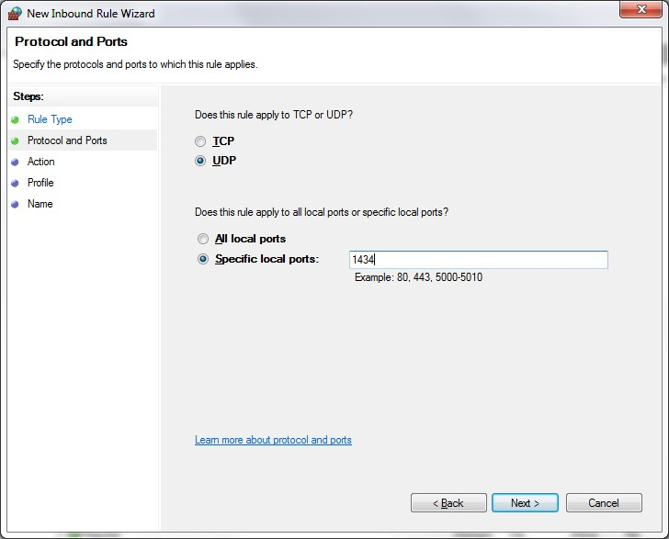

**Figure 3.26 – New Inbound Rule Wizard (Protocol and Ports) Dialog Box**

18. Click **Next**.

19. Click the **Allow the connection** option.



**Figure 3.27 – New Inbound Rule Wizard (Action) Dialog Box**

20. Click **Next**.

21. Select the **Domain** check box.



**Figure 3.28 – New Inbound Rule Wizard (Profile) Dialog Box**

22. Click **Next**.

23. Give this rule a name, such as **SQL Server Browser**.



**Figure 3.29 – New Inbound Rule Wizard (Name) Dialog Box**

24. Click **Finish**.

**Installing SQL Server Express 2012 for Advanced Users**

This section is a quick start guide for advanced users. To install SQL Server Express 2012:

1. Ensure the following settings are on the judge’s PC:

• Mixed Mode Authentication

• SQL Server Browser service set to start automatically

• The user that will install the SessionWorks Services.msi package as an administrator on

the SQL Express database.

2. Enable TCP/IP connections.

3. Create two Domain-only Windows Firewall rules. Create one for SQL Express and one for UDP

port1434.

**SQL Server Express Mixed Mode**

You may have an existing SQL Server Express installation that was installed in Windows Authentication Mode only. You must set the instance to be in **Mixed Mode**.

**Enable Mixed Mode (SQL Server and Windows) Authentication**

There are two different methods to set the instance to be in **Mixed Mode**:

• Through SQL Server Management Studio

• Through the registry

Choose the method that you are most comfortable with. If you did not install the SQL Server tools, it is recommended that you modify the registry directly. If one of these methods is not sufficient, a Google search can assist you.

**Enabling Mixed Mode Authentication Through SQL Server**

**Management Studio**

This section provides step-by-step instructions for enabling **Mixed Mode** authentication through SQL Server Managment Studio. Complete the following steps to enable **Mixed Mode** authentication through SQL Server Management Studio:

1. Open SQL Server Management Studio.

2. Connect to the SQLEXPRESS instance.

3. Right-click the **SQL Server** instance, and then select **Properties**.

4. Select **Security** in the left window.

5. Select the **SQL Server and Windows Authentication** mode.

6. Click **OK**.

7. Right-click the **SQL Server** instance, and then select **Restart**.

**Enabling Mixed Mode Authentication Through the Registry**

This section provides step-by-step instructions for enabling **Mixed Mode** authentication through the registry. Complete the following steps to enable **Mixed Mode** authentication through the registry:

1. Open **regedit**.

2. Open the key HKEY_LOCAL_MACHINE\SOFTWARE\Microsoft\Microsoft SQL

Server\MSSQL10.SQLEXPRESS\MSSQLServer.

3. Set the **LoginMode** value to **2**.

4. Restart SQL Server (either through SQL Server Management Studio or SQL Server

Configuration Manager. See the **Enabling Mixed Mode Authentication Through SQL Server**

**Management Studio** section for instructions.)

**Install SessionWorks Judge Edition Rights**

Judges must have the appropriate rights assigned to their role to gain access to SessionWorks Judge Edition.

**Assigning Judge Edition Rights to Judges**

Complete the following steps to assign “Judge Edition” rights to judges:

1. Open Odyssey and click on Administration in the working space.

2. Click **Roles** from the **Security** section of the navigation menu.

3. Click **Case Manager Roles** from the **Product Center Roles** section.

4. Create a role, or select an existing role to modify.

5. Click the **Session Works** tab in the **Rights Listing** section.

6. Select the **Access Judge Edition** check box.

7. Click **Save**.

Kane needs to add the user “cicjudge” to Stage site.

Judges with the role you modified now have the rights to access Judge Edition.

**Judge Edition Installation**

There are three parts to installing SessionWorks Judge Edition:

• Deploy SessionWorks Judge Edition

• Install Odyssey SessionWorks Services

• Install Odyssey SessionWorks Judge Edition

**Deploying SessionWorks Judge Edition**

After Tech Services installs Judge Edition on the client’s server using the IMS console, the Administration Site is updated with links for the SessionWorks Services installer and the SessionWorks Judge Edition application installer.

1. In order to access the deployment page, you must sign on with a user that has rights to deploy

Odyssey Assistant. This right can be found on your System role (Case Manager > **Administration**

> **Roles** > **System Roles** > Select role > **Administration** tab).

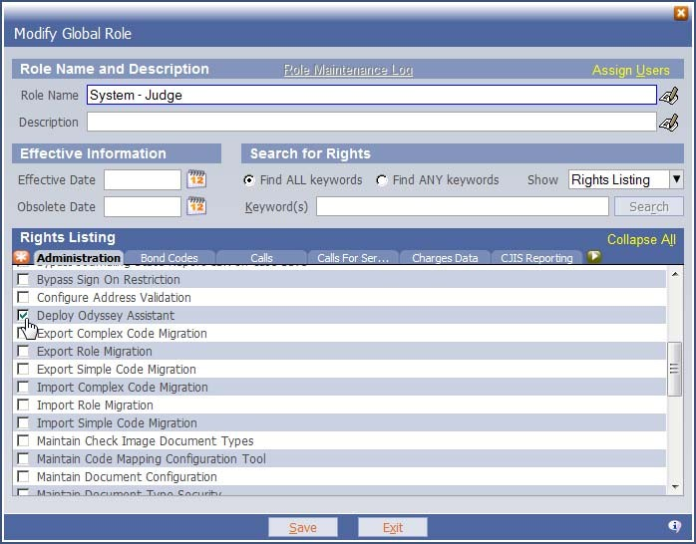

2. Judge Edition is deployed from the Odyssey Administration site.

**Example**: **http://PRIMARY site info/administrationsite**

**http://JUDODYAPPT1/administrationsite**

To find the PRIMARY site info, open Odyssey Case Manager, click HELP, then choose ABOUT ODYSSEY. Look at the name after PRIMARY: and copy it into the web browser address bar.

3. Click **Deployment** to access the logon screen where you can type your username and password.

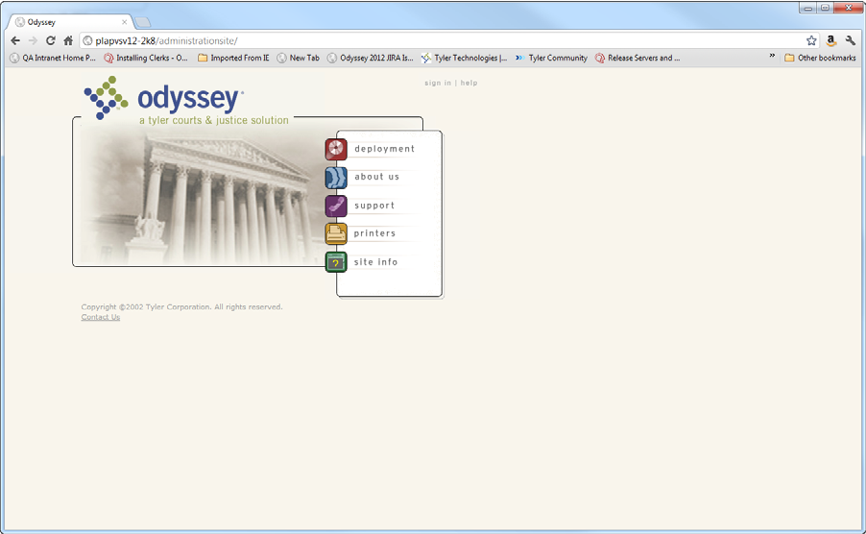

Type in your user name and password, and then click **sign in**.

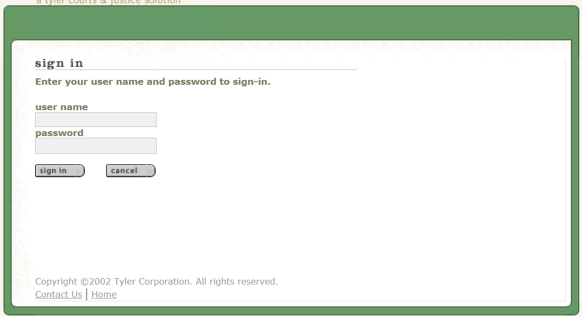

You will be taken to the Odyssey **products deployment** screen.

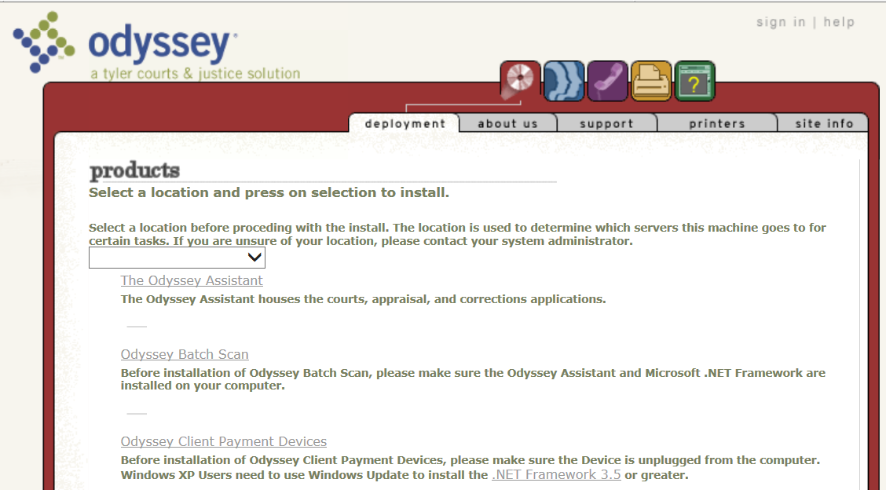

4. Use the drop down to select the ODY site, and click the **Odyssey SessionWorks Services** link.

**Installing Odyssey SessionWorks Services**

SessionWorks Services are used to retrieve the case data from the Odyssey database. The SessionWorks Services should be installed on the machine that will serve as the direct line of

Communication with Odyssey, i.e. will receive the nightly download of sessions/hearings/cases from

Odyssey’s court calendar. This is usually the PC on the judge’s bench.

**NOTE: If the PC Judge Edition will be installed on is running Windows 8, you may get an error message at some point during the installation of Central Services or Judge Edition. If you receive the error pop up box, CLICK MORE INFORMATION, then click OK.**

1. To begin installation, click the **Odyssey SessionWorks Services** link on the **Deployment**

page.

2. Click **Next** on the first screen of the SessionWorks Services Wizard.

3. Complete the central service options displayed, and click **Next**.

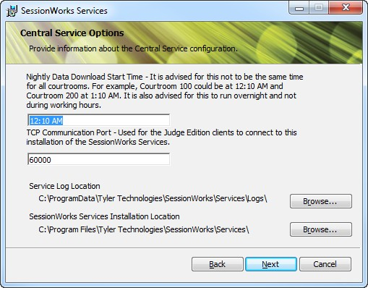

|  |  |
| --- | --- |
| **Field Name** | **Description** |
| **Nightly Download Start Time** | In conversation this is also referred to as the “Overnight Process.” The  overnight process retrieves all of the hearing and case data from Case Manager. It is recommended this happens overnight so the data has completed download prior to court starting in the morning. This time can be changed or additional times can be added through the Odyssey System Administration Console at a later time. |
| **TCP Communication Port** | The default value is 60000. This is the communication port used between the Central Service and the Client Applications, so they all need to be the same number. |
| **Service Log**  **Location** | Tyler recommends leaving the default in this field so it can always be found by support. |
|  |  |
| **SessionWorks Services Installation Location** | Tyler recommends leaving the default in this field so it can always be found by support. |

4. Judge Edition stores downloaded data locally so the case file is always available. This dialog

box defaults the local SQL express instance, **Core Database Name**, and the **Site Database**

**Name**. Tyler recommends you leave the default values here, and click **Next**.

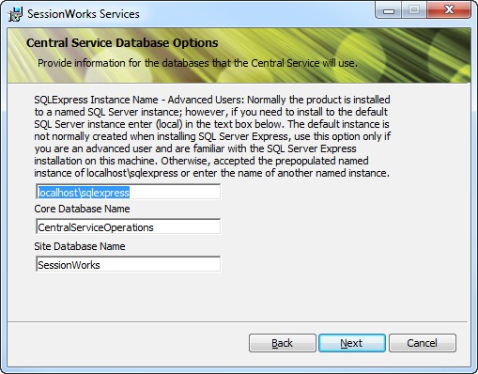

5. Enter the **Application Server Name** of the site you want to install Judge Edition with, and click **Next**.

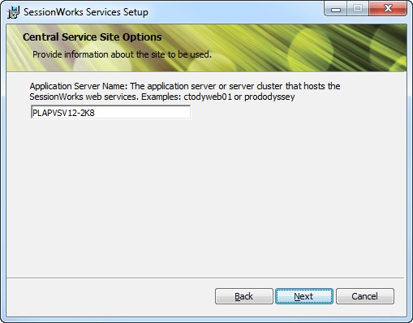

This information is available in the Odyssey Assistant under **Help** > **About Odyssey**.

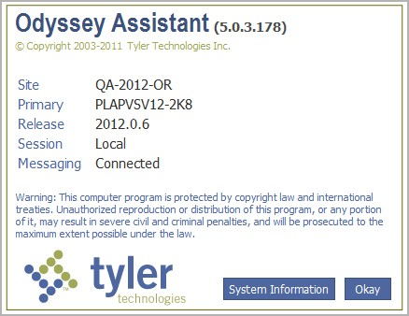

6. Complete the central service web service options displayed, and click **Next**.

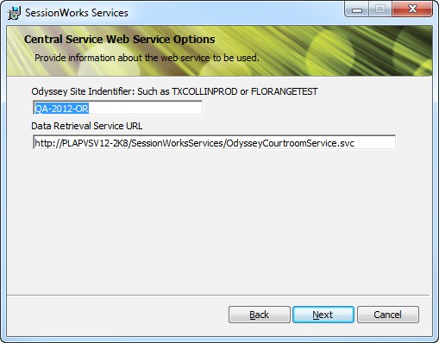

NOTE: If you get have a problem connecting to the URL in step 6 and see the following issue:

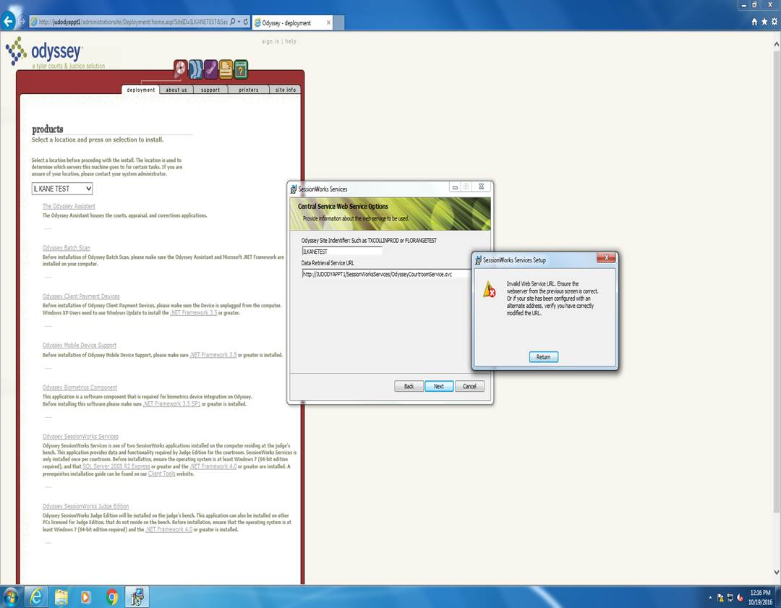

The resolution is to go to IMS and choose your realm you are attempting to connect to and go to IMS Configuration tab ->System Settings -> Under Realm in the navigation bar, Judge Edition HTTPS Configuration. Then check mark force communications for JE call over unsecured HTTP. Then you must resync judge edition.

The following fields are available:

|  |  |
| --- | --- |
| **Field Name** | **Description** |
| **Odyssey Site**  **Identifier** | Correct capitalization is required for the Odyssey Site Identifier. |
| **Data Retrieval**  **Service URL** | Tyler recommends leaving the default in this field. |

7. Complete the central service document options displayed, and click **Next**.

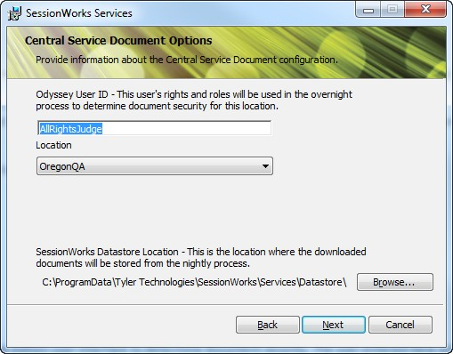

The following fields are available.

|  |  |
| --- | --- |
| **Field Name** | **Description** |
| **Odyssey User**  **ID** | Enter the user ID that will be used for document security. Judge Edition does not use the user currently logged into the Judge Edition user interface to determine document security. The user entered here will be used to determine which documents can be viewed. See sections 3.3.1.4 – 3.3.1.7 of the Session Works Judge Edition SRS for more details. |
| **Location** | Select the location for the documents. If there is more than one option, select the location closest to you. |
| **SessionWorks Datastore Location** | Tyler recommends leaving the default in this field. |

8. Select **New Location** if this is the first time Judge Edition is being installed. If you are

Re-installing Judge Edition, select **Restore Location**. Click **Next**.

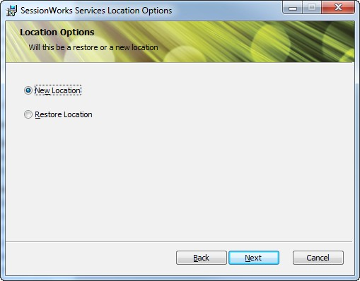

9. Complete the location options displayed, and click **Next**.

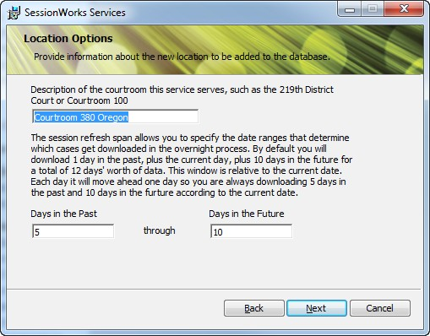

The following fields are available.

|  |  |
| --- | --- |
| **Field Name** | **Description** |
| **Description of the courtroom** | Enter a description of the courtroom this service setup uses. |
| **Days in the Past / Days in the Future** | Enter the days in the past and future case data should be downloaded for from Case Manager. Judge Edition will not download any data or show any previously downloaded data outside of this range. |

10. Click **Install**.

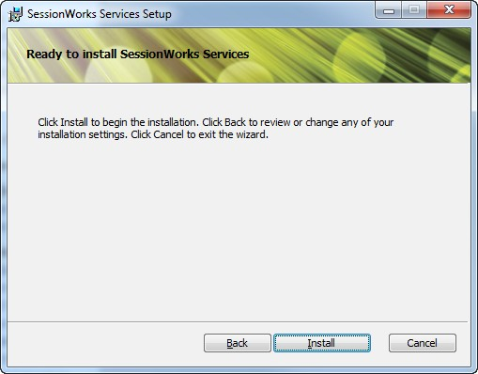

11. Click **Finish** to complete the SessionWorks Services installation.

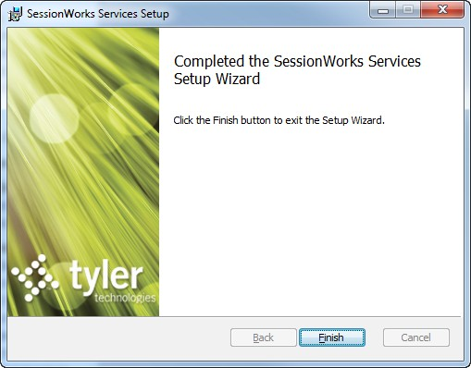

**Collaborative Courtroom Setup**

If a court has purchased Judge Edition licenses for other users beside the judge, such as judicial assistants, clerks, or bailiffs, then it is recommended that the Central Services (and the Judge Edition application) be installed on the judge’s bench, while only the Judge Edition application is installed on the other users’ machines. In the Client Application installation instructions, this document will explain how to point these users machines to the judge’s machine running the services so the courtroom can function in a collaborative way.

**Installing Odyssey SessionWorks Judge Edition**

Complete the following steps to install Odyssey SessionWorks Judge Edition:

**NOTE: If the PC Judge Edition will be installed on is running Windows 8, you may get an error message at some point during the installation of Central Services or Judge Edition. If you receive the error pop up box, CLICK MORE INFORMATION, then click OK.**

1. Click the **Odyssey SessionWorks Judge Edition** link on the **Deployment** page.

2. Click **Next** to begin walking through the Judge Edition Client Application wizard.

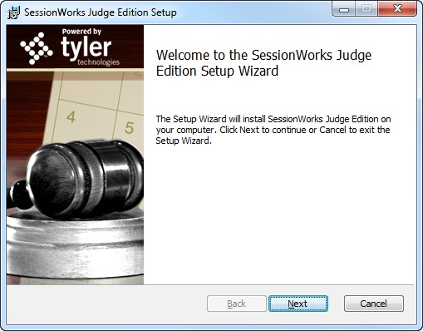

. Complete the location options displayed, and click **Next**.

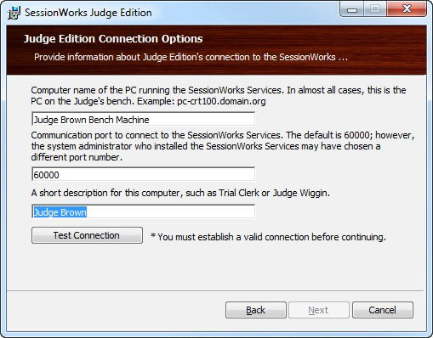

The following fields are available.

|  |  |
| --- | --- |
| **Field Name** | **Description** |
| **Computer name** | Enter the name of the machine where the SessionWorks Services were installed. This information allows other users machines running just the application to point back to the machine running the services, therefore setting up a collaborative courtroom. The machine’s name can be found by clicking the Start Menu and then clicking COMPUTER. The machine name will appear at the bottom of the box that is displayed. |
| **Communication port** | Leave the default port number as 60000. This should be the same numbered entered for the TCP communication Port for the services installed on the machine named here. |
| **Short description** | Enter a short description for this computer. This description is not being used for anything at this time, but please enter a good value. |

Click **Test Connection** to verify this machine can connect back to the machine running the SessionWorks Services. After a successful connection to the SessionWorks Services is made, click **Return**, and then click Next

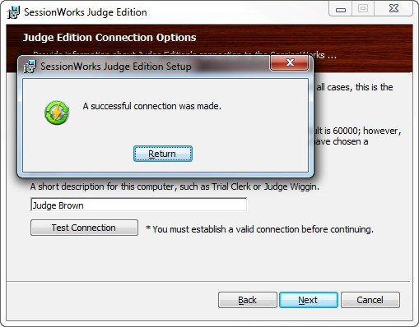

4. Select the location you wish to connect to. This should be the location description created for the SessionWorks Services. It is recommended to leave the default log locations so users and Tyler support can easily find them if necessary. Select ‘Next’ on the Judge Edition location choice page of the wizard.

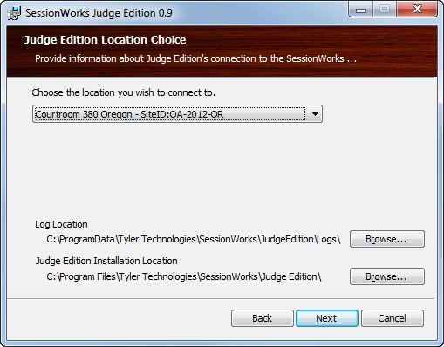

5. Click **Install** to begin the installation of the Judge Edition application.

6. Click **Finish** to complete the installation. The Judge Edition application has now been added to your desktop.

Once launched, the application prompts for a user name and password. Rights to access Judge Edition are available on the Case Manager role of the Odyssey Case Manager user access record. The right is called “Access Judge Edition.”

After logging on, the application prompts for resource configuration. Configure the judge, magistrate, or location setup on the calendar sessions being downloaded into Judge Edition. If your location was being restored during installation, you will not be prompted for this information.

1. Select a resource.

a. From the **Configuration** page, click the **Resources** button.

b. Select a judge, location, or magistrate to be the resource.

2. To connect to multiple courtrooms, select a connection. ***Note: This is an optional step.***

a. From the **Configuration** page, click the **Connections** button.

b. Select a connection from the list.

3. Verify the **Case Detail** selections. ***Note: This is an optional step.***

a. From the **Configuration** page, click the **Case Detail** button.

b. Select **Tyler Criminal** from the **CR** drop‐down list.

c. Select **Tyler Non‐Criminal** from the **CV**, **PR**, and **FAM** drop‐down lists.

d. Click **Save**.

You are now ready to begin using Odyssey SessionWorks Judge Edition.

NOTE: Only one session of JE may be loaded on a machine.

NOTE: JE must be uninstalled and reinstalled if it needs to point to a different realm/site than the current session installed.

Caution: To uninstall JE you must do this in the opposite order in which installed. Uninstall JE first then Session Works Services second. If not done in this order it can cause serious issues to the computer.